Which two of the following responsibilities does a Pega Business Architect have as part of their daily activities? (Choose Two)

response - correct

Responses

* 1

Listen to insights from IT regarding Pega-centric out-of-the-box automations to address business requirements.

Listen to insights from IT regarding Pega-centric out-of-the-box automations to address business requirements. - correct

* 2

Set up the interface that connects the Pega application to an external database.

Set up the interface that connects the Pega application to an external database. - no response given

* 3

Configure testing scripts and scenarios to ensure the functionality of specific application features.

Configure testing scripts and scenarios to ensure the functionality of specific application features. - no response given

* 4

Use App Studio to demonstrate how the Business team's requirements are met using out-of-the-box capabilities of Pega Platform.

Use App Studio to demonstrate how the Business team's requirements are met using out-of-the-box capabilities of Pega Platform. - correct

**Correct**

4

Correct. Promoting the use of out-of-the-box capabilities of Pega Platform features supports low-code application development best practices.

1

Correct. Gathering feedback from IT stakeholders ensures that the project maxmizes the out-of-the-box capabilities of Pega Platform while addressing business process requirements.

Which two of the following stakeholders does the Pega Business Architect (BA) typically partner with to manage the scope of project and prioritize application deliverables? (Choose Two)

* Project Delivery Lead (PDL)

Correct answer.

Correct. The PDL, sometimes called the Project Manager, is responsible for ensuring that the project deliver is on time and on budget. The Pega BA works with the PDL, Project Owner, and Scrum Master to ensure stakeholders from both the Business and IT teams align in their expectations for the timing and cost of project deliverables.

* System Architects (SAs)
* Product Owner (PO)

Correct answer.

Correct. The PO is primarily responsible for managing the scope of the project and prioritizing deliverables throughout the software development process. The Pega BA works closely with the PO, Project Delivery Lead, and Scrum Master to ensure that the Pega Platform application delivers the project's strategic outcomes in the expected time frame.

* Quality Analysts (QAs)

Javi is a Pega Business Architect (BA) working on a project redesigning a fraud resolution process. Stakeholders from the Business team want the Manager of the Fraud department to continue manually distributing tasks to the CSRs. But both Javi and the IT team, understanding the Workflow Automation capabilities of Pega Platform™, know that the task routing can be automated using business logic.

What skill must Javi use to get the Business team to incorporate IT's proposed solution into the business process?

Responses

* 

Communication and facilitation

Communication and facilitation - correct

* 

Process design

Process design - no response given

* 

Change management

Change management - no response given

* 

Analytical

Analytical - no response given

Feedback

You can check answer feedback only once for each question. However, you can change your answer at any time. Once selected, click Next to save your answer.

**Correct**

1

Javi uses their communication and facilitation skills to help Business understand how Pega's out-of-the-box capabilities can meet their business needs.

Anna is a Pega Business Architect (BA). The project that Anna is currently working on uses the Agile delivery approach. Which of the project stakeholders does Anna coordinate with to ensure that a software bug discovered by the project's Quality Analyst does not negatively affect the project's scope?

Responses

* 

Product Owner

Product Owner - correct

* 

Subject Matter Expert (SME)

Subject Matter Expert (SME) - no response given

* 

System Architect (SA)

System Architect (SA) - no response given

* 

Business Analyst

Business Analyst - no response given

Feedback

You can check answer feedback only once for each question. However, you can change your answer at any time. Once selected, click Next to save your answer.

**Correct**

1

The Business Architect interacts with the Product Owner for teams that use the Agile delivery approach to ensure that the project stays on time and in scope.

As a Pega Business Architect (BA), which three stakeholders from the project team do you collaborate with to mange the scope, timeline, and budget for a project? (Choose Three)

response - correct

Responses

* 1

System Architect

System Architect - no response given

* 2

Product Owner

Product Owner - correct

* 3

Project Delivery Lead

Project Delivery Lead - correct

* 4

Scrum Master

Scrum Master - correct

* 5

Business Analyst

Business Analyst - no response given

Feedback

You can check answer feedback only once for each question. However, you can change your answer at any time. Once selected, click Finish to save your answer.

**Correct**

2

Pega BAs collaborate closely with the Product Owner to ensure that the Pega Platform application delivers the project's strategic outcomes in the expected time frame.

3

Pega BAs collaborate closely with the PDL to ensure that the project stays on time, on budget, and in scope so that stakeholders from both the Business and IT teams are aligned in their expectations for the timing and cost of project deliverables.

4

Pega BAs work with the project Scrum Master to mange the timeline of the project through Scrum ceremonies such as sprint planning meetings.

Drag the words into the correct boxes

In Pega's

Center-out

 business architecture, the

Presentation layer

 contains the delivery channels , the

Data access layer

 contains the systems of record, and the

Application layer

, which is always at the center, contains the business logic needed to achieve the strategic outcome for the organization and the customer.

Which three of the follow choices are among Pega's OOTB capabilities for workflow automation? (Choose Three)

* Skill-based assignment routing

Correct answer.

Correct. Automated routing is one of Pega's most valuable workflow automation tools. Assignments can be routed to specific individuals, work queues, or can be based on defined business logic.

* Service-Level Agreements

Correct answer.

Correct. Service-Level Agreements ensure that work is completed on-time, and the associated escalation actions make sure the delay is addressed when work is late.

* Automated notifications

Correct answer.

Correct. Automated notifications ensure that all stakeholders are kept up to data on the status of the Process or Case throughout its life cycle.

* Manual handoffs
* Inconsistent data gathering

Examples of AI in Pega Platform applications include the use of

natural language ...

 to convert unstructured text into actionable data,

predictive analytics

 to anticipate missed deadlines, and

process mining

 to resolve operational inefficiencies.

App Studio is a low-code development workspace for Citizen developers and System Architects alike.

True

False

**Correct. App Studio is designed for low-code users. Typical users include application developers, front-end developers, data engineers, and business analysts.**

 supports agile methodology by providing the

App Studio

 workspace for low-code application development.

What is the purpose of a Rule in a Pega Platform application?

* A Rule is a template for creating a Rule type and determines the behavior modeled for the Rule type.
* A Rule is an instruction for describing a specific case behavior, such as a process or automated decision.

Correct answer.

Correct. A Rule describes behavior of individual cases.

* A Rule is an instruction for describing a specific case behavior that is highly specialized and is not reusable.
* A Rule is a specific case behavior that you must create and manage in Dev Studio.

What is the purpose of a class in a Pega Platform application?

* A work class organizes rules that describe how the application interacts with other systems.
* An integration class organizes rules that describe the data types in the application.
* A data class organizes rules that describe how to process a case or cases.
* A class organizes rules within an application based on their capacity for reuse.

Correct answer.

Correct. Pega Platform groups rules according to their capacity for reuse.

he current version of a travel booking application sends automated booking confirmation emails that include the wrong Customer name and Case number. How do you address this issue?

* Create a major version of the relevant Ruleset to correct the email content.
* Create a patch version of the relevant Ruleset to correct the email content.

Correct answer.

Correct. Patch versions are appropriate for bug fixes.

* Create a new Ruleset to correct the email content.
* Create a minor version of the relevant Ruleset to correct the email content.

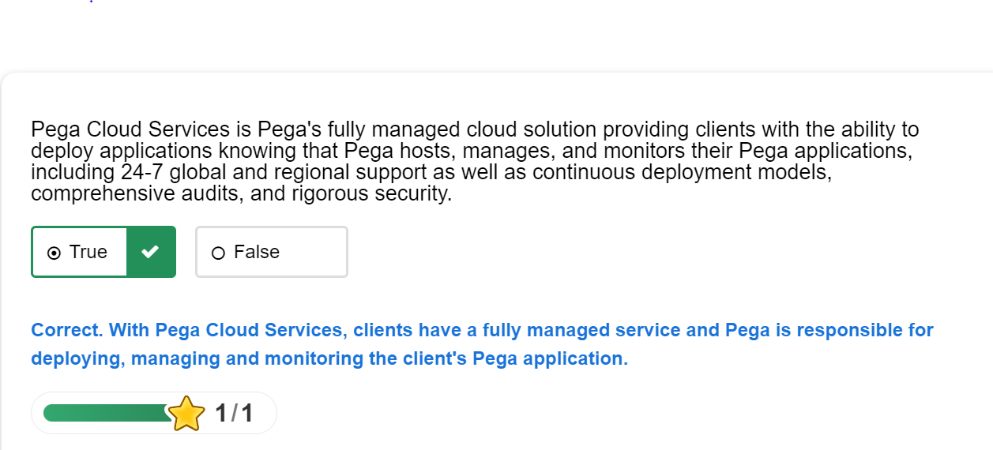

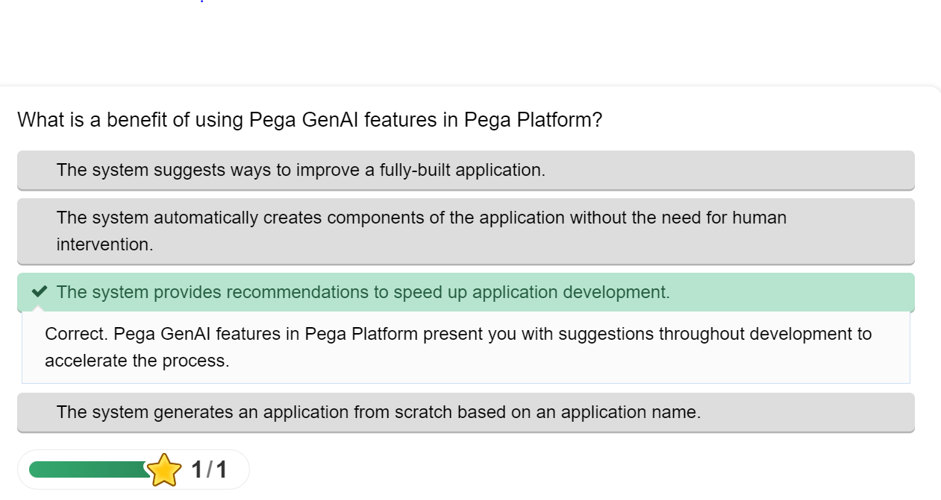

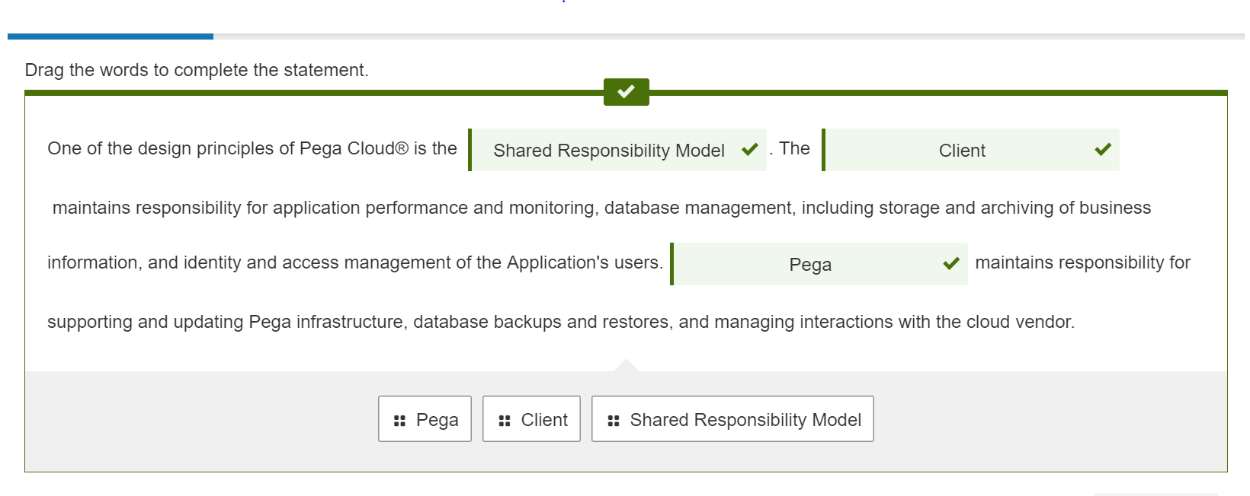

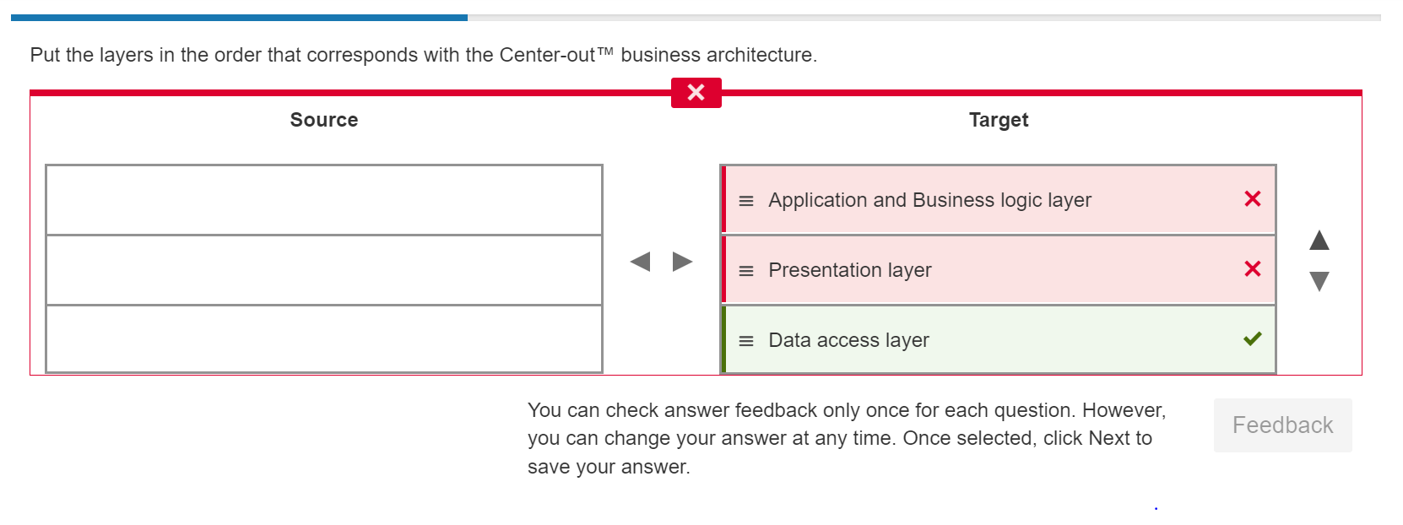

Presentation

Application

Data access layer

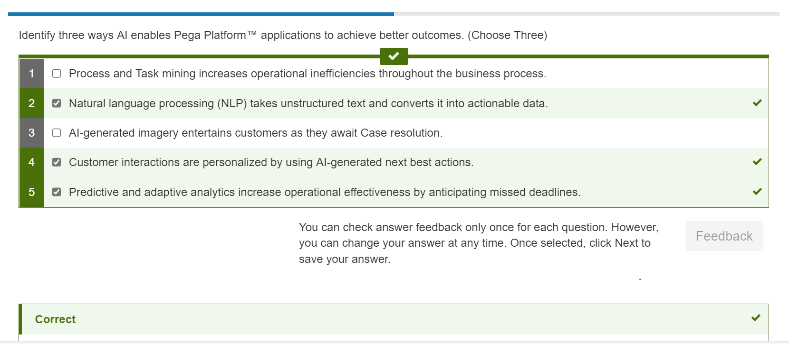

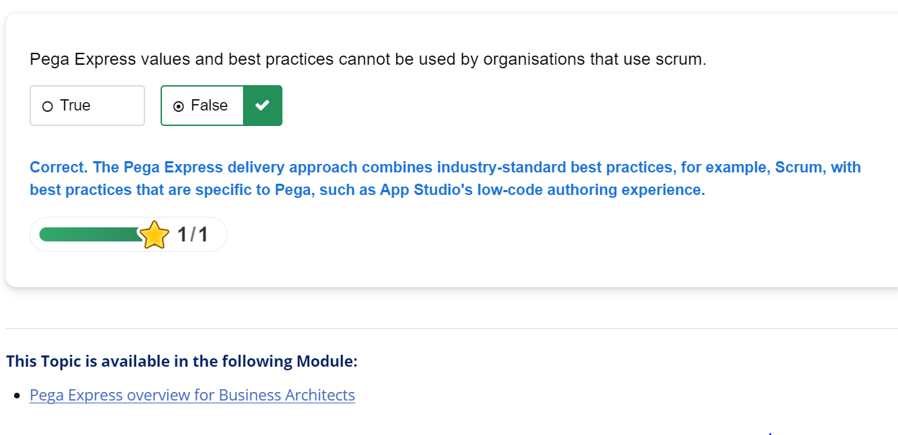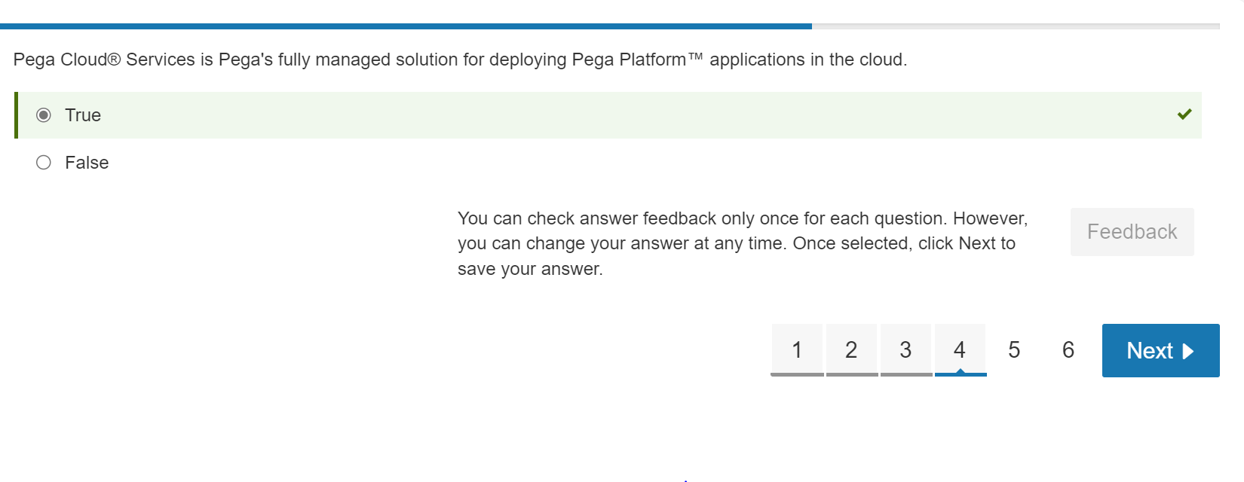

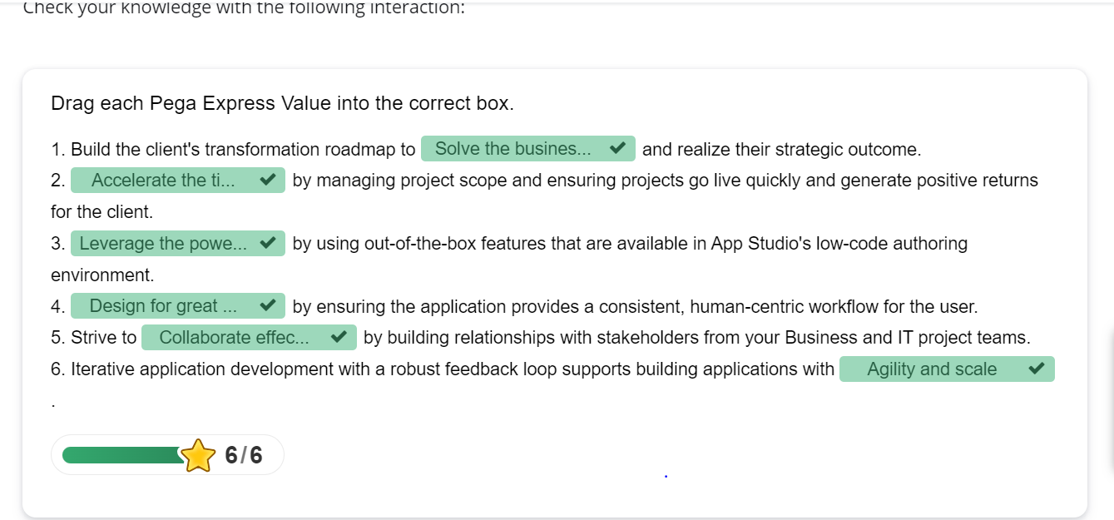

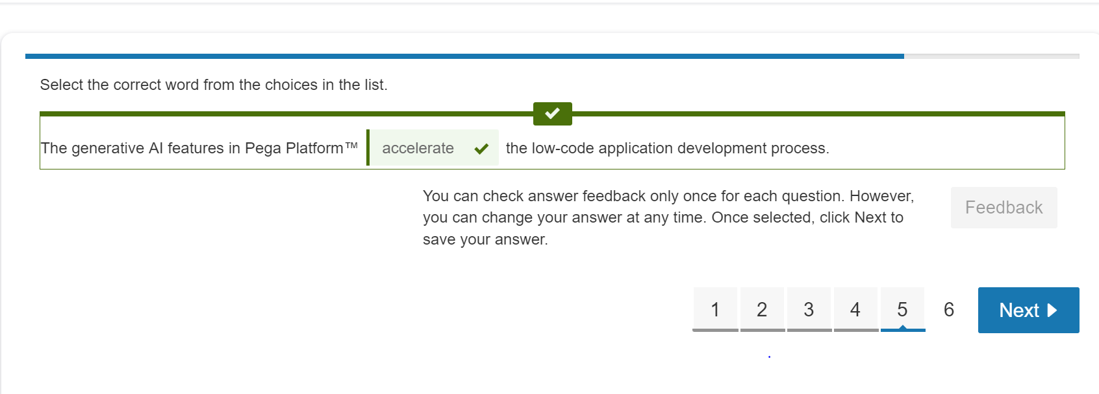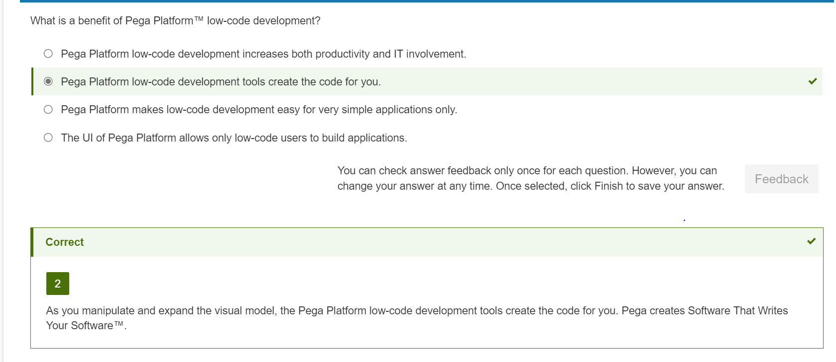

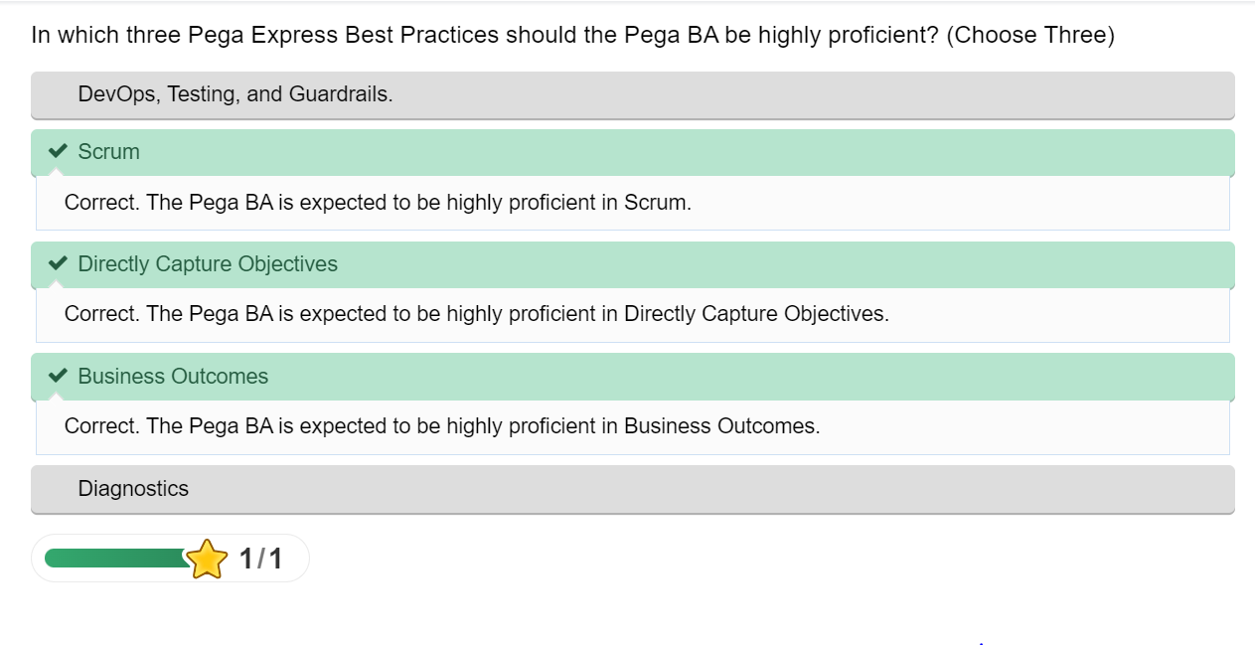

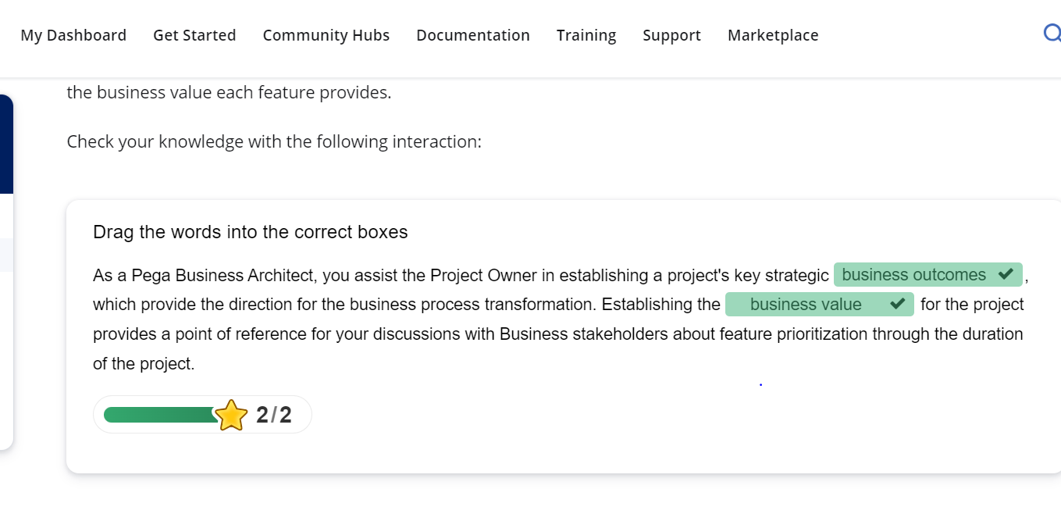

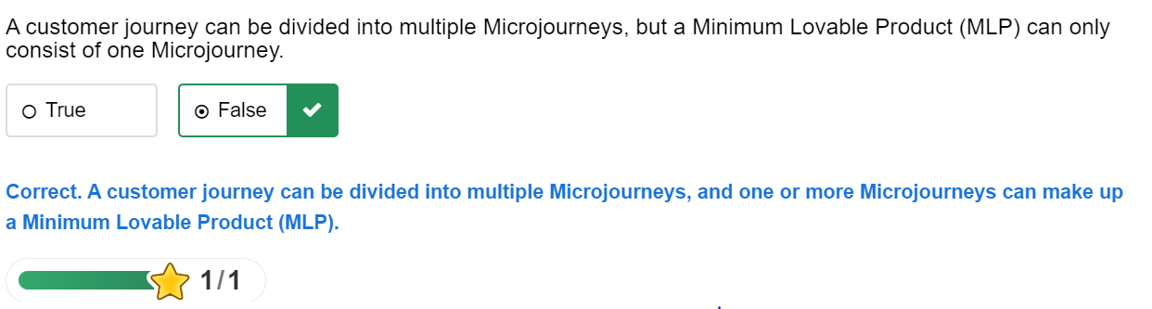

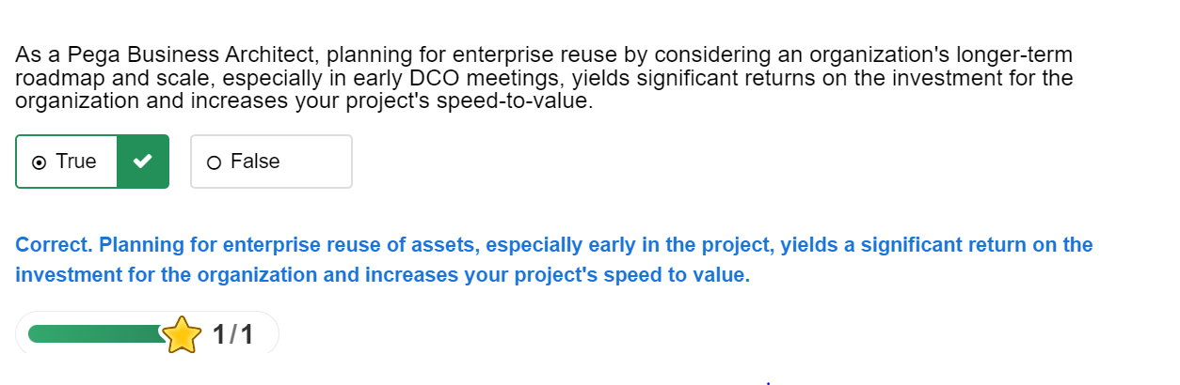

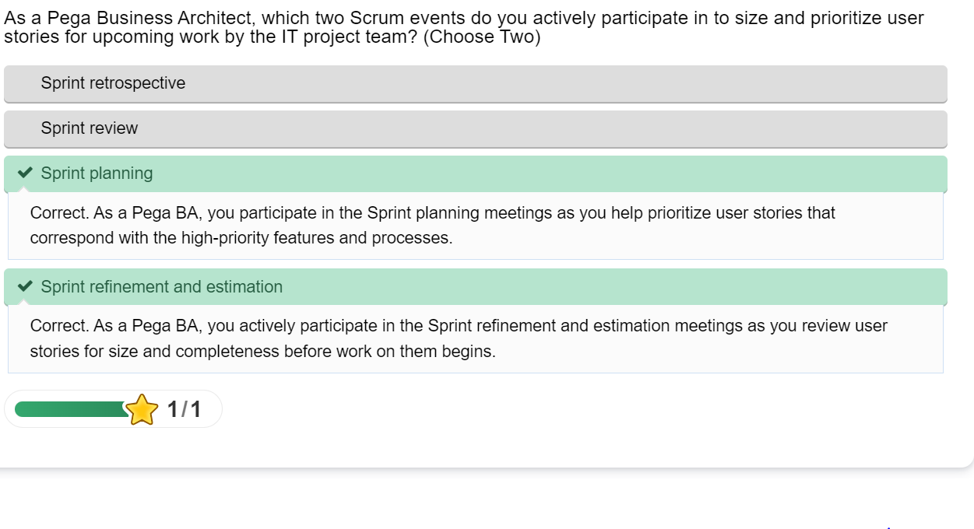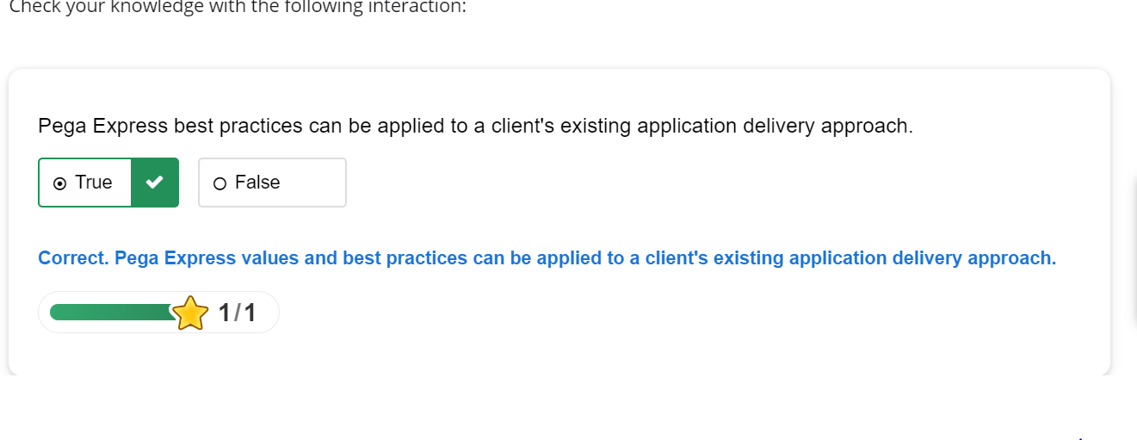

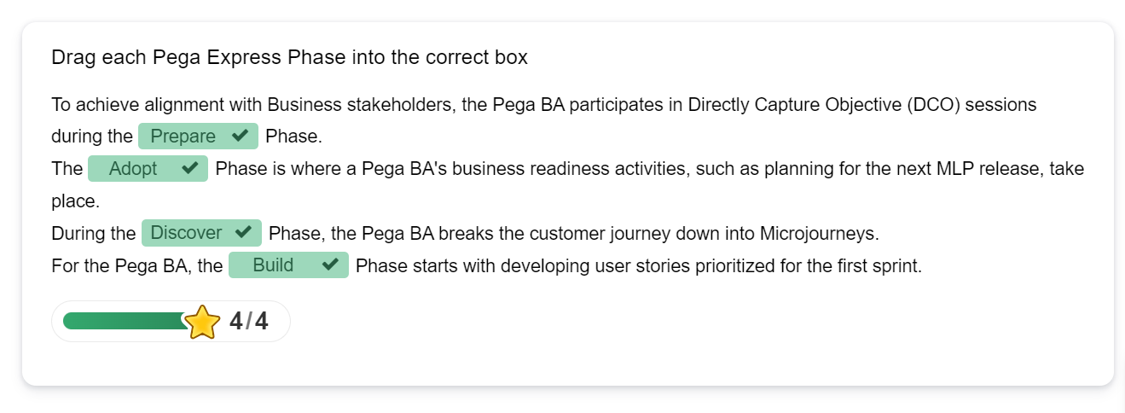

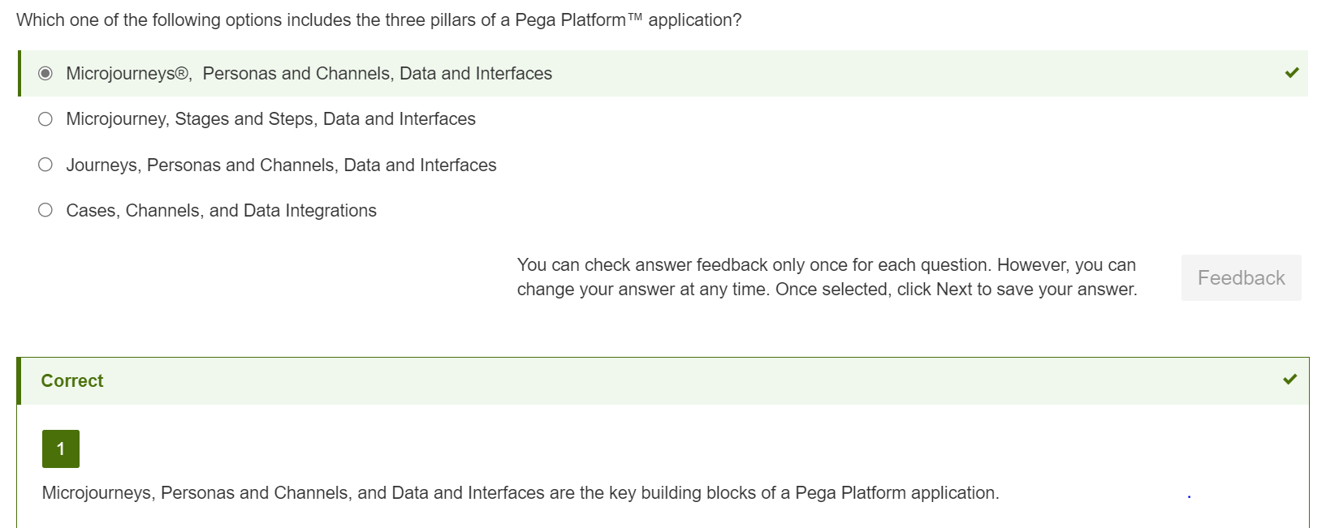

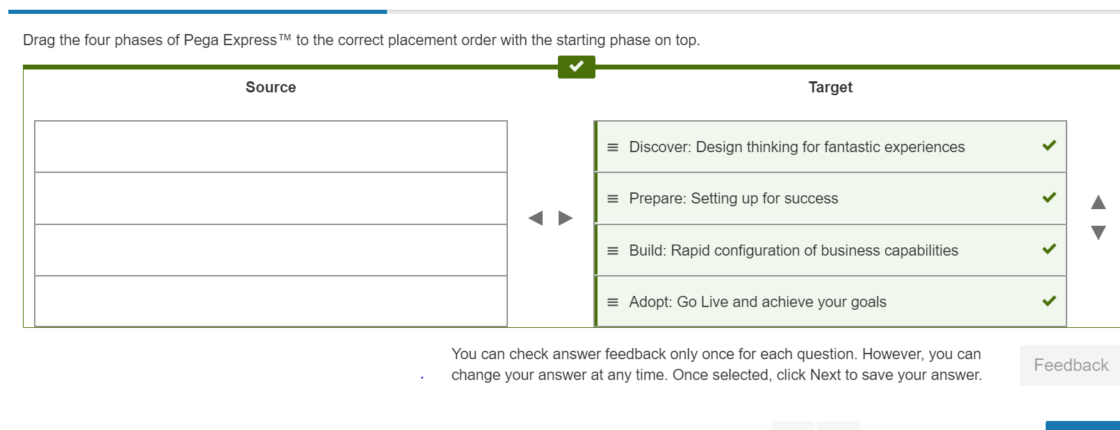

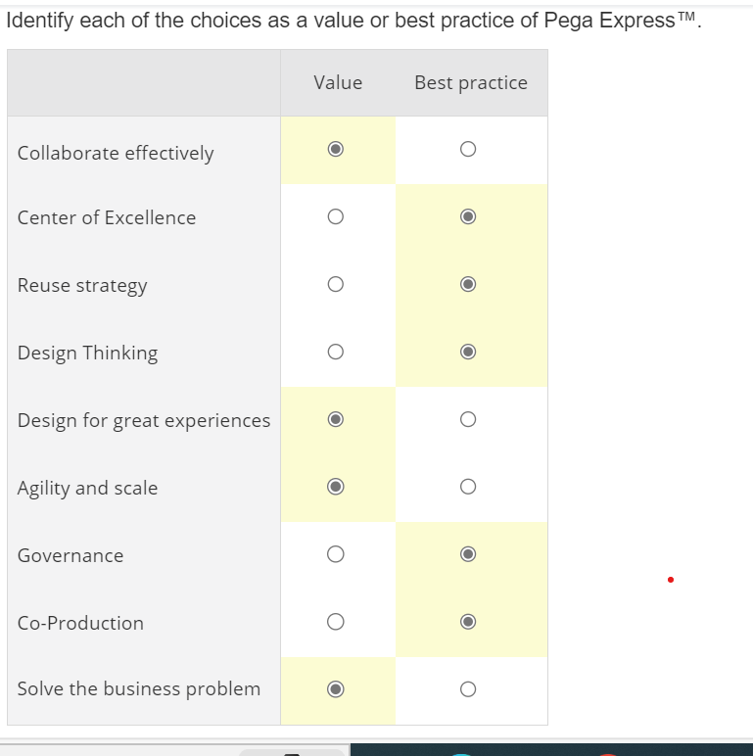

Correct answer

